| ASSIGNMENT DATE | 8 SEPTEMBER 2022 |
| --- | --- |
| STUDENT NAME | ROHIT.D |
| STUDENT ROLL NO. | 19EC128 |
| MAXIMUM MARKS | 2 MARKS |

**Challenge:**

Upload the dataset to Cognos Analytics,prepare a data set,explore and create an interactive dashboard.

**Solution:**

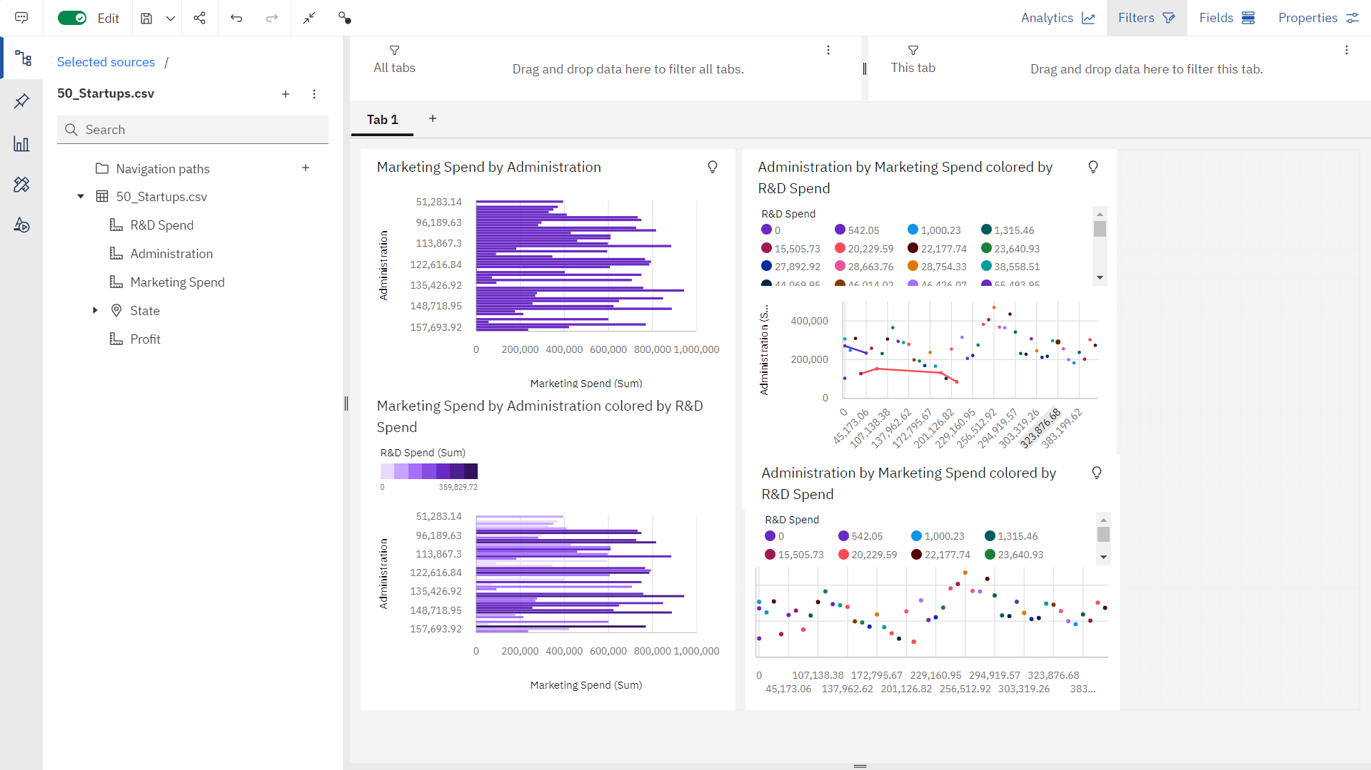

**REFERENCE LINK:**

**https://us3.ca.analytics.ibm.com/bi/?perspective=dashboard&pathRef=.my_folders%2Fassignment3&action=view&mode=dashboard&subView=model00000183b31631cd_00000000**